**BMS COLLEGE OF ENGINEERING**

**BULL TEMPLE ROAD, BANGALORE-560018**

**DEPARTMENT OF COMPUTER SCIENCE AND ENGINEERING**

Academic Semester Aug-Dec 2017



**LAB MANUAL**

**ON**

**INTERNET OF THINGS**

16CS5DCIOT

Faculty In-Charge

|  |  |  |
| --- | --- | --- |
| Dr.Jyothi Nayak  5th Sem A Section | Mr.Basavaraj J  5th Sem B, Section | Panimozhi K  5th Sem C, Section |

**Content Of Lab Manual**

|  |  |  |
| --- | --- | --- |
| **Sl.No** | **Content** | **Pg. No** |
|  | **IoT Overview** | **3** |
|  | **Introduction to Arduino** | **4** |
|  | **Arduino Development Board** | **5-7** |
|  | **Experiment List** |  |
|  | 1. LED Blinking/ LED ON/OFF Using Pushbutton/ LED Fading | **8-12** |
|  | 1. Traffic Controller | **12** |
|  | 1. LDR | **13** |
|  | 1. PIR | **14** |
|  | 1. Home Automation | **16** |
|  | 1. Fire Alert | **20** |
|  | 1. Automatic irrigation controller simulation | **22** |
|  | 1. Reverse parking sensor (Using LCD Display) | **24** |
|  | 1. RFID reader and RFID tag count | **26** |
|  | 1. Wifi | **30** |
|  |  |  |
|  |  |  |

**1. Internet of Things**

The Internet of Things (IoT) describes the phenomenon of everyday devices connecting to the Internet through tiny embedded sensors and computing power

We’re entering a new era of computing technology that many are calling the Internet of Things (IoT). Machine to machine, machine to infrastructure, machine to environment, the Internet of Everything, the Internet of Intelligent Things, intelligent systems—call it what you want, but it’s happening, and its potential is huge.  We see the IoT as billions of smart, connected “things” that will encompass every aspect of our lives, and its foundation is the intelligence that embedded processing provides. The IoT is comprised of smart machines interacting and communicating with other machines, objects, environments and infrastructures.

**Applications of IoT**

* Machine-to-machine communication
* Machine-to-infrastructure communication
* Telehealth: remote or real-time pervasive monitoring of patients, diagnosis and drug delivery
* Continuous monitoring of, and firmware upgrades for, vehicles
* Asset tracking of goods on the move
* Automatic traffic management
* Remote security and control
* Environmental monitoring and control
* Home and industrial building automation
* “Smart” applications, including cities, water, agriculture, buildings, grid, meters, broadband, cars, appliances, tags, animal farming and the environment, to name a few.

**2. Introduction to Arduino**

The Arduino board is a small microcontroller board, which is a small circuit (the board) that contains a whole computer on a small chip (the microcontroller). Arduino is composed of two major parts: the Arduino board, which is the piece of hardware you work on when you build your objects; and the Arduino IDE, the piece of software you run on your computer. You use the IDE to create a sketch (a little computer program) that you upload to the Arduino board. The sketch tells the board what to do.

The Arduino software is easy-to-use for beginners, yet flexible enough for advanced users. It runs on Mac, Windows, and Linux. Teachers and students use it to build low cost scientific instruments, to prove chemistry and physics principles, or to get started with programming and robotics. It has the specific advantages such as

• **Inexpensive** - Arduino boards are relatively inexpensive compared to other microcontroller platforms. The least expensive version of the Arduino module can be assembled by hand, and even the pre-assembled Arduino modules cost less than $50

• **Cross-platform** - The Arduino Software (IDE) runs on Windows, Macintosh OSX, and Linux operating systems. Most microcontroller systems are limited to Windows.

• **Simple, clear programming environment** - The Arduino Software (IDE) is easy-to-use for beginners, yet flexible enough for advanced users to take advantage of as well. For teachers, it's conveniently based on the Processing programming environment, so students learning to program in that environment will be familiar with how the Arduino IDE works.

• **Open source and extensible software** - The Arduino software is published as open source tools, available for extension by experienced programmers. The language can be expanded through C++ libraries, and people wanting to understand the technical details can make the leap from Arduino to the AVR C programming language on which it's based. Similarly, you can add AVR-C code directly into your Arduino programs if you want to.

• **Open source and extensible hardware** - The plans of the Arduino boards are published under a Creative Commons license, so experienced circuit designers can make their own version of the module, extending it and improving it. Even relatively inexperienced users can build the breadboard version of the module in order to understand how it works and save money.

**Installing Arduino on Your Computer**

To program the Arduino board, you must first download the development environment (the IDE) from here: [www.arduino.cc/en/Main/Software](http://www.arduino.cc/en/Main/Software). Choose the right version for your operating system. Download the file and double-click on it to open it it; on Windows or Linux, this creates a folder named arduino-[version], such as arduino-1.0. Drag the folder to wherever you want it: your desktop, your Program Files folder (on Windows), etc. On the Mac, double-clicking it will open a disk image with an Arduino application (drag it to your Applications folder). Now whenever you want to run the Arduino IDE, you’ll open up the arduino (Windows and Linux) or Applications folder (Mac), and double-click the Arduino icon.

**Difference between Microprocessor and Microcontroller**

|  |  |
| --- | --- |
| **Microprocessor** | **Micro Controller** |
| Description: 1G mobile phone | Description: 1G mobile phone |
| Microprocessor is heart of Computer system. | Micro Controller is a heart of embedded system. |
| It is just a processor. Memory and I/O components have to be connected externally | Micro controller has external processor along with internal memory and i/O components |
| Since memory and I/O has to be connected externally, the circuit becomes large. | Since memory and I/O are present internally, the circuit is small. |
| Cannot be used in compact systems and hence inefficient | Can be used in compact systems and hence it is an efficient technique |
| Cost of the entire system increases | Cost of the entire system is low |
| Due to external components, the entire power consumption is high. Hence it is not suitable to used with devices running on stored power like batteries. | Since external components are low, total power consumption is less and can be used with devices running on stored power like batteries. |
| Most of the microprocessors do not have power saving features. | Most of the micro controllers have power saving modes like idle mode and power saving mode. This helps to reduce power consumption even further. |
| Since memory and I/O components are all external, each instruction will need external operation, hence it is relatively slower. | Since components are internal, most of the operations are internal instruction, hence speed is fast. |
| Microprocessor have less number of registers, hence more operations are memory based. | Micro controller have more number of registers, hence the programs are easier to write. |
| Microprocessors are based on von Neumann model/architecture where program and data are stored in same memory module | Micro controllers are based on Harvard architecture where program memory and Data memory are separate |
| Mainly used in personal computers | Used mainly in washing machine, MP3 players |

## **3. The Arduino Development board**

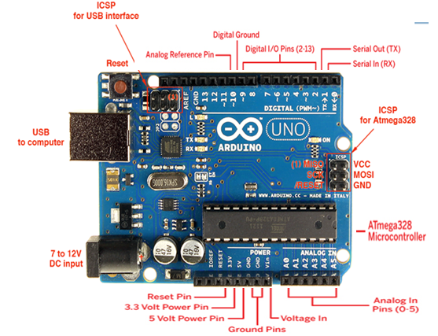

### **Digital Pins**

The digital pins on an Arduino board can be used for general purpose input and output via the [pinMode()](https://www.arduino.cc/en/Reference/PinMode), [digitalRead()](https://www.arduino.cc/en/Reference/DigitalRead), and [digitalWrite()](https://www.arduino.cc/en/Reference/DigitalWrite) commands. Each pin has an internal pull-up resistor which can be turned on and off using digitalWrite() (w/ a value of HIGH or LOW, respectively) when the pin is configured as an input. The maximum current per pin is 40 mA.

Some other specific functions of pins are listed below:

* **Serial: 0 (RX) and 1 (TX).** Used to receive (RX) and transmit (TX) TTL serial data
* **External Interrupts: 2 and 3.** These pins can be configured to trigger an interrupt on a low value, a rising or falling edge, or a change in value.
* **PWM: 3, 5, 6, 9, 10, and 11.** Provide 8-bit PWM output with the [analogWrite()](https://www.arduino.cc/en/Reference/AnalogWrite) function. On boards with an ATmega8, PWM output is available only on pins 9, 10, and 11.
* **BT Reset: 7.** (Arduino BT-only) Connected to the reset line of the bluetooth module.
* **SPI: 10 (SS), 11 (MOSI), 12 (MISO), 13 (SCK).** These pins support SPI communication, which, although provided by the underlying hardware, is not currently included in the Arduino language.
* **LED: 13.** There is a built-in LED connected to digital pin 13. When the pin is HIGH value, the LED is on, when the pin is LOW, it's off.

### **Analog Pins**

In addition to the specific functions listed below, the analog input pins support 10-bit analog-to-digital conversion (ADC) using the [analogRead()](https://www.arduino.cc/en/Reference/AnalogRead) function. Most of the analog inputs can also be used as digital pins: analog input 0 as digital pin 14 through analog input 5 as digital pin 19. Analog inputs 6 and 7 (present on the Mini and BT) cannot be used as digital pins.

### **Power Pins**

* **VIN**: The input voltage to the Arduino board when it's using an external power source (as opposed to 5 volts from the USB connection or other regulated power source). You can supply voltage through this pin, or, if supplying voltage via the power jack, access it through this pin.
* **5V.** The regulated power supply used to power the microcontroller and other components on the board. This can come either from VIN via an on-board regulator, or be supplied by USB or another regulated 5V supply.
* **3V3.**  A 3.3 volt supply generated by the on-board FTDI chip.
* **GND.** Ground pins.

### **Other Pins**

* **AREF.** Reference voltage for the analog inputs. Used with [analogReference](https://www.arduino.cc/en/Reference/AnalogReference)().
* **Reset.**  Bring this line LOW to reset the microcontroller. Typically used to add a reset button to shields which block the one on the board.

**4. Programs**

**1.**

**LED Blinking**

**Aim**

Turns on an LED on for one second, then off for one second, repeatedly

**Hardware Required**

* Arduino Board
* LEDs

**Circuit Diagram**

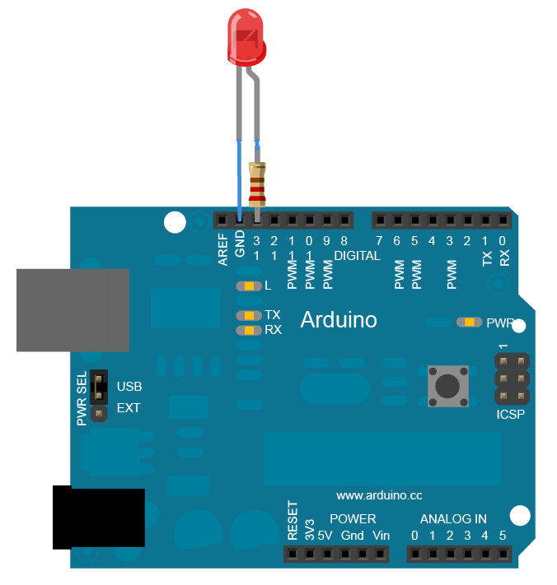

**Code**

// Pin 13 has an LED connected on most Arduino boards

int led = 13;  
  
void **setup**()  // the setup routine runs once when you press reset

{                  
// initialize the digital pin as an output.  
  pinMode(led, OUTPUT);       
}  
  
void **loop**() { // the loop routine runs over and over again forever  
  digitalWrite(led, HIGH);   // turn the LED on (HIGH is the voltage level)  
  delay(1000);               // wait for a second  
  digitalWrite(led, LOW);    // turn the LED off by making the voltage LOW

  delay(1000);               // wait for a second  
}

**LED ON/OFF Using Pushbutton**

**Aim**

Turn an LED ON /OFF using a Pushbutton.

**Hardware Required**

* Arduino Board
* LED
* Push button

**Circuit Diagram**

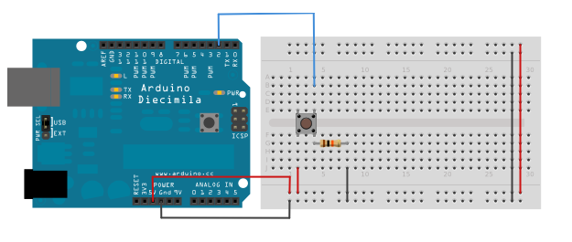



**Code:**

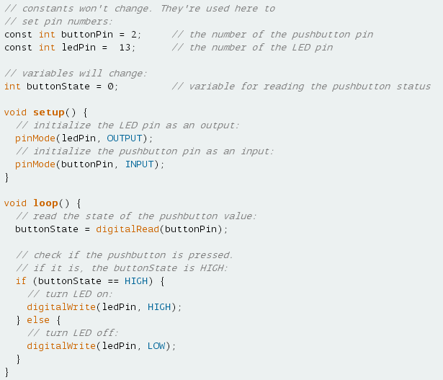

**LED Fading using Potentiometer**

**Aim**

To control the brightness of an LED using a Potentiometer.

**Hardware Required**

* Arduino Board
* LED
* Potentiometer.

**Circuit Diagram**

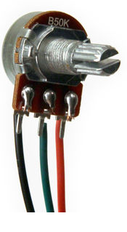 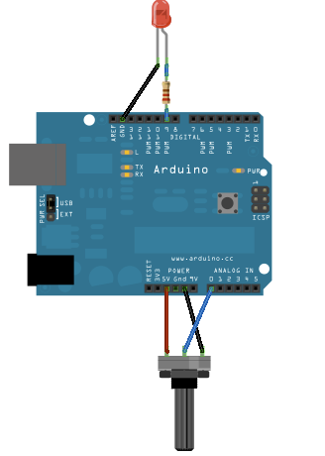

**Code:**

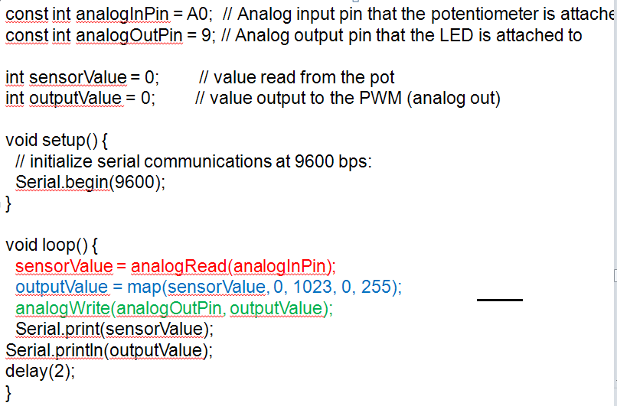

**2. Traffic Controller**

**Aim**

Traffic Signal Simulation

**Hardware Required**

* Arduino Board
* LEDs
* Resistors – 10 K
* Bread board

**Circuit Diagram**

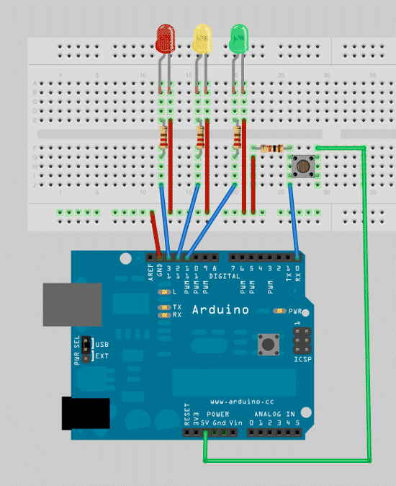

**Code**

**// defining variables so that we can address the lights by name rather than a number**

int red = 13;

*int yellow = 12;*

*int green = 11;*

**//** **add the setup function, where’ll we define the red, yellow and green LEDs to be output mode**

void setup()

{

pinMode(red,OUTPUT);

pinMode(yellow,OUTPUT);

pinMode(green,OUTPUT);

}

void loop()

{

changeLights();

delay(15000);

}

void changeLights(){

// green off, yellow for 3 seconds

digitalWrite(green,HIGH);

digitalWrite(yellow,LOW);

delay(3000);

// turn off yellow, then turn red on for 5 seconds

digitalWrite(yellow,LOW);

digitalWrite(red,HIGH);

delay(5000);

// red and yellow on for 2 seconds (red is already on though)

digitalWrite(yellow,HIGH);

delay(2000);

// turn off red and yellow, then turn on green

digitalWrite(yellow,LOW);

digitalWrite(red,LOW);

digitalWrite(green,HIGH);

}

# **3. Nightlight Simulation**

**Aim**

Simulating a night light using LDR

**Hardware Required**

* 1 LED
* 1 LDR
* 110K register

[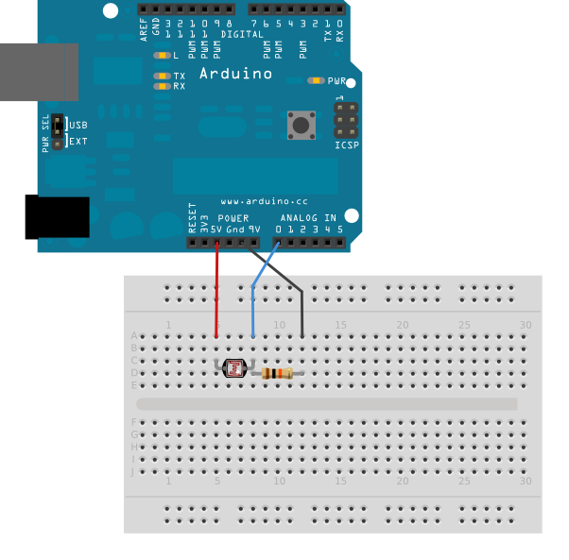](http://arduino.cc/en/uploads/Tutorial/switchCase_bb.png)

**Connection:**

1. Attach one leg of LDR to 5V and another leg to Arduino Analog pin A0
2. Attach one leg of 110K register with that leg of LDR connected to A0
3. Attach another leg of register to the ground
4. Connect the positive leg of LED to pin 11 and negative to GND

**Code:**

int LDR = 0; //analog pin to which LDR is connected, here we set it to 0 so it means A0

int LDRValue = 0; //that’s a variable to store LDR values

int light_sensitivity = 500; //This is the approx value of light surrounding your LDR

void setup()

{

Serial.begin(9600); //start the serial monitor with 9600 buad

pinMode(11, OUTPUT); //attach positive leg of LED to pin 11

}

void loop()

{

LDRValue = analogRead(LDR); //reads the ldr’s value through LDR

Serial.println(LDRValue); //prints the LDR values to serial monitor

delay(50); //This is the speed by which LDR sends value to arduino

if (LDRValue < light_sensitivity)

{

digitalWrite(11, HIGH);

}

else

{

digitalWrite(11, LOW);

}

delay(1000);

}

**Observation:**

While lights are switched off in the room, LED should switch ON, when lights are switched on in the room, LED should switch off immediately.

# **4. Human Presence Detection**

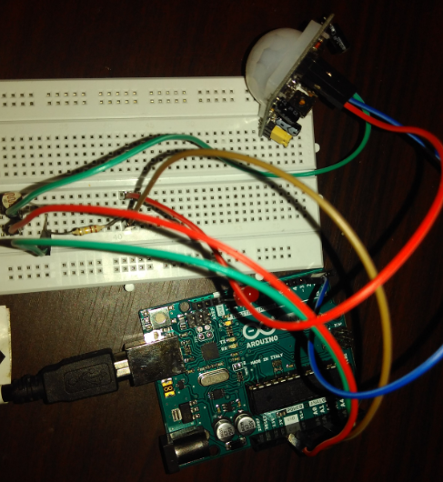

**Hardware Required**

* 1 LED
* 110K register
* 1 PIR

**Understanding the configuration of PIR sensor:**

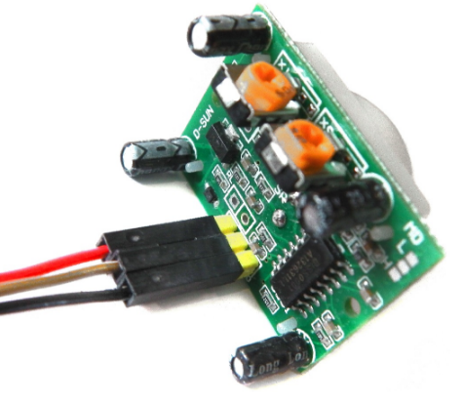

**Connection:**

1. Connect the positive leg of LED to pin 11 and negative to GND
2. Connect positive leg of PIR to 5V and negative leg to GND
3. Connect output pin of PIR to digital pin 3

**Code:**

**//the time we give the sensor to calibrate (10-60 secs according to the datasheet)**

**int calibrationTime = 30;**

**//the time when the sensor outputs a low impulse**

**long unsigned int lowIn;**

**//the amount of milliseconds the sensor has to be low**

**//before we assume all motion has stopped**

**long unsigned int pause = 5000;**

**boolean lockLow = true;**

**boolean takeLowTime;**

**int pirPin = 3; //the digital pin connected to the PIR sensor's output**

**int ledPin = 13;**

**/////////////////////////////**

**//SETUP**

**void setup(){**

**Serial.begin(9600);**

**pinMode(pirPin, INPUT);**

**pinMode(ledPin, OUTPUT);**

**digitalWrite(pirPin, LOW);**

**//give the sensor some time to calibrate**

**Serial.print("calibrating sensor ");**

**for(int i = 0; i < calibrationTime; i++){**

**Serial.print(".");**

**delay(1000);**

**}**

**Serial.println(" done");**

**Serial.println("SENSOR ACTIVE");**

**delay(50);**

**}**

**////////////////////////////**

**//LOOP**

**void loop(){**

**if(digitalRead(pirPin) == HIGH){**

**digitalWrite(ledPin, HIGH); //the led visualizes the sensors output pin state**

**if(lockLow){**

**//makes sure we wait for a transition to LOW before any further output is made:**

**lockLow = false;**

**Serial.println("---");**

**Serial.print("motion detected at ");**

**Serial.print(millis()/1000);**

**Serial.println(" sec");**

**delay(50);**

**}**

**takeLowTime = true;**

**}**

**if(digitalRead(pirPin) == LOW){**

**digitalWrite(ledPin, LOW); //the led visualizes the sensors output pin state**

**if(takeLowTime){**

**lowIn = millis(); //save the time of the transition from high to LOW**

**takeLowTime = false; //make sure this is only done at the start of a LOW phase**

**}**

**//if the sensor is low for more than the given pause,**

**//we assume that no more motion is going to happen**

**if(!lockLow && millis() - lowIn > pause){**

**//makes sure this block of code is only executed again after**

**//a new motion sequence has been detected**

**lockLow = true;**

**Serial.print("motion ended at "); //output**

**Serial.print((millis() - pause)/1000);**

**Serial.println(" sec");**

**delay(50);**

**}**

**}**

**}**

**Steps and Observation:**

1. Upload the program to Arduino and open Serial monitor
2. It will show in Serial monitor: **calibrating sensor .............................. done**
3. Wait until it is shown: **SENSOR ACTIVE**
4. Make some movement near PIR
5. LED should keep glowing for some time
6. While LED is ON, switch on the light, LED should switch off immediately.

**5. Home automation**

**Aim:**

To control the working of relay through Android Mobile.

**Hardware Required:**

* Arduino
* 4-Channel relay
* Bluetooth Module
* Android phone

**Circuit diagram**

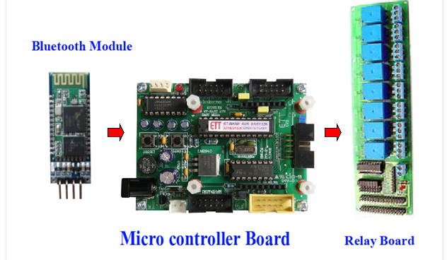

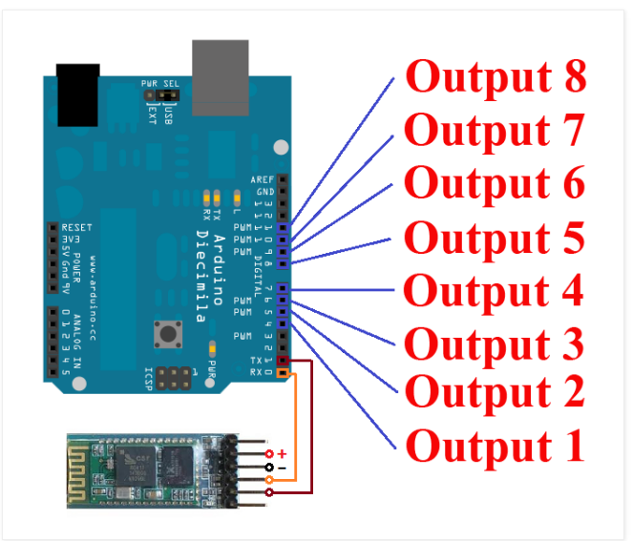

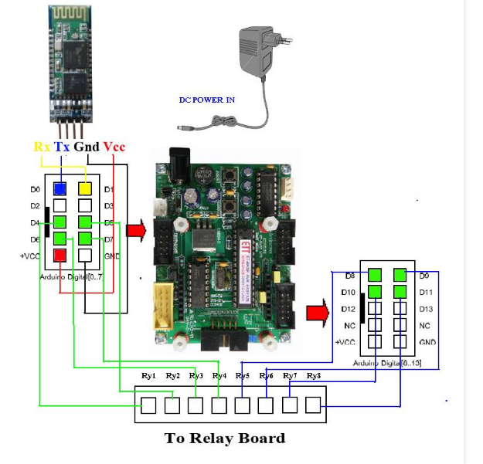

Wiring Arduino Pin Diagram

Output 1 to Pin 4 ( Arduino Board )  
Output 2 to Pin 5  
Output 3 to Pin 6  
Output 4 to Pin 7

Bluetooth Module Tx to Pin 0  
Bluetooth Module Rx to Pin 1  
======================

VCC of Bluetooth & relay should be connected to Arduino 5V(through breadboard)

GND of Bluetooth & relay should be connected to Arduino GND

**Important:**

* **First upload the code to Arduino and then connect Bluetooth module**
* **Install Arduino Bluetooth device App in your android mobile**

A data transmission via Bluetooth.  
Device1 ON sent “a” , Device1 OFF sent “A”   
Device2 ON sent “b” , Device2 OFF sent “B”   
Device3 ON sent “c” , Device3 OFF sent “C”   
Device4 ON sent “d” , Device4 OFF sent “D”

**Code:**

/*

Simple LED test

*/

char val; // variable to receive data from the serial port

int ledpin = 2; // LED connected to pin 2 (on-board LED)

void setup()

{

pinMode(ledpin = 2, OUTPUT); // pin 2 (on-board LED) as OUTPUT

pinMode(ledpin = 3, OUTPUT); // pin 3 (on-board LED) as OUTPUT

pinMode(ledpin = 4, OUTPUT); // pin 4 (on-board LED) as OUTPUT

pinMode(ledpin = 5, OUTPUT); // pin 5 (on-board LED) as OUTPUT

Serial.begin(9600); // start serial communication at 9600bps

}

void loop()

{

if( Serial.available() ) // if data is available to read

{

;

}

val = Serial.read(); // read it and store it in 'val'

if( val == 'a' ) // if 'a' was received led 2 is switched off

{

digitalWrite(ledpin = 2, HIGH); // turn Off pin 2

}

if( val == 'A' ) // if 'A' was received led 2 on

{

digitalWrite(ledpin = 2, LOW); // turn ON pin 2

}

if( val == 'b' ) // if 'b' was received led 3 is switched off

{

digitalWrite(ledpin = 3, HIGH); // turn Off pin 3

}

if( val == 'B' ) // if 'B' was received led 3 on

{

digitalWrite(ledpin = 3, LOW); // turn ON pin 3

}

if( val == 'C' ) // if 'C' was received

{

digitalWrite(ledpin=4, LOW); // turn Off pin 4

}

if( val == 'D' ) // if 'D' was received

{

digitalWrite(ledpin=5, LOW); // turn Off pin 5

}

if( val == 'c' ) // if 'c' was received

{

digitalWrite(ledpin = 4, HIGH); // turn On pin 4

}

if( val == 'd' ) // if 'd' was received

{

digitalWrite(ledpin = 5, HIGH); // turn ON pin 5

}

}

**6. Fire Alert**

**Aim**

Fire alarm simulation

**Hardware Required**

* Flame sensor (Analogue Output)
* Arduino
* Bread board
* LED
* Buzzer
* Connecting wires

**Circuit Diagram**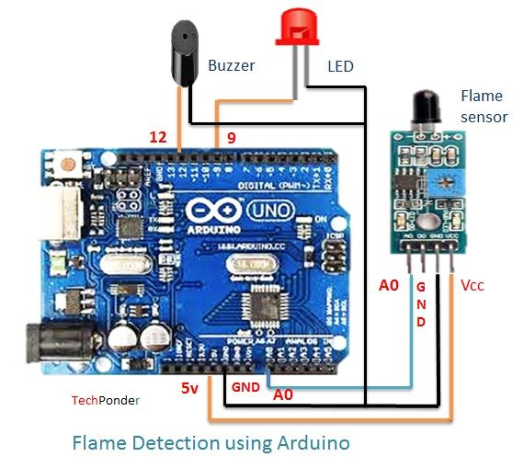

**Flame sensor interfacing to Arduino**

Flame sensor to Arduino

vcc -> vcc

gnd -> gnd

A0 -> A0

**Led interfacing to Arduino**

**LED +ve** is connected to **9th pin** of Arduino

**LED -ve** is connected to **gnd pin** of arduino

**Buzzer interfacing to Arduino**

**Buzzer +ve** is connected to **12th pin** of Arduino

**Buzzer -ve** is connected to **GND** pin of Arduino

**Code:**

#include<SoftwareSerial.h>

int sensorPin = A0; // select the input pin for the LDR

int sensorValue = 0; // variable to store the value coming from the sensor

int led = 9; // Output pin for LED

int buzzer = 12; // Output pin for Buzzer

void setup() {

// declare the ledPin and buzzer as an OUTPUT:

pinMode(led, OUTPUT);

pinMode(buzzer,OUTPUT);

Serial.begin(9600);

}

void loop()

{

Serial.println("Welcome to TechPonder Flame Sensor Tutorial");

sensorValue = analogRead(sensorPin);

Serial.println(sensorValue);

if (sensorValue < 100)

{

Serial.println("Fire Detected");

Serial.println("LED on");

digitalWrite(led,HIGH);

digitalWrite(buzzer,HIGH);

delay(1000);

}

digitalWrite(led,LOW);

digitalWrite(buzzer,LOW);

delay(sensorValue);

}

**7. Automatic irrigation controller simulation**

**Aim**

Sensing the soil moisture and sprinkling the Water simulation

**Hardware Required**

* Arduino
* Moisture Sensor
* Breadboard
* Min servo motor

**Circuit diagram**

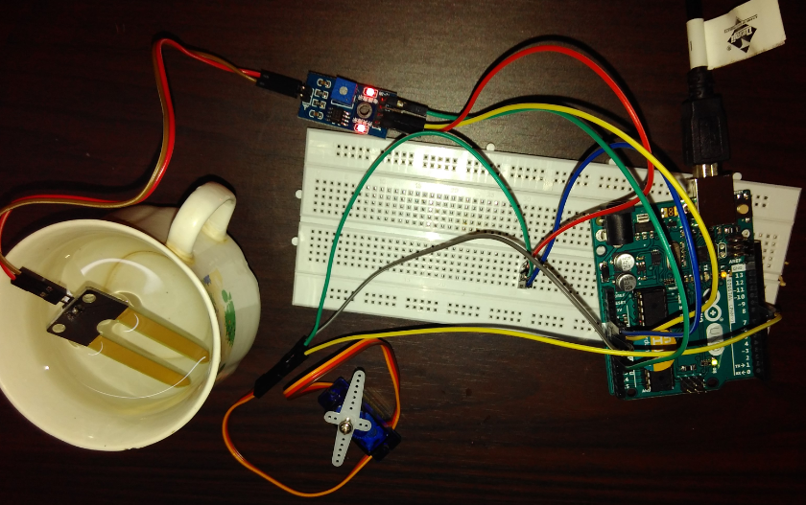

Moisture sensor VCC to Arduino 5V

Moisture sensor GND to Arduino GND

Moisture sensor A0 to Arduino A0

Servo motor VCC to Arduino 5V

Servo motor GND to Arduino GND

Servo Motor Signal to Arduino digital pin 9

Code:

#include <Servo.h>

Servo myservo; // create servo object to control a servo

// twelve servo objects can be created on most boards

int pos = 0; // variable to store the servo position

int sensorPin = A0; // select the input pin for the potentiometer

int sensorValue = 0; // variable to store the value coming from the sensor

void setup() {

myservo.attach(9); // attaches the servo on pin 9 to the servo object

Serial.begin(9600);

}

void loop() {

// read the value from the sensor:

sensorValue = analogRead(sensorPin);

Serial.println (sensorValue);

if(sensorValue>500)

{

for (pos = 0; pos <= 180; pos += 1) { // goes from 0 degrees to 180 degrees

// in steps of 1 degree

myservo.write(pos); // tell servo to go to position in variable 'pos'

delay(15); // waits 15ms for the servo to reach the position

}

for (pos = 180; pos >= 0; pos -= 1) { // goes from 180 degrees to 0 degrees

myservo.write(pos); // tell servo to go to position in variable 'pos'

delay(15); // waits 15ms for the servo to reach the position

}

}

delay (1000);

}

**8. Reverse parking sensor (Using LCD)**

**Aim**

Measuring the distance using Ultrasonic sensor which helps in reverse parking system.

**Hardware Required**

* Arduino
* Ultrasonic Sensor
* Breadboard
* LCD

**Circuit diagram**

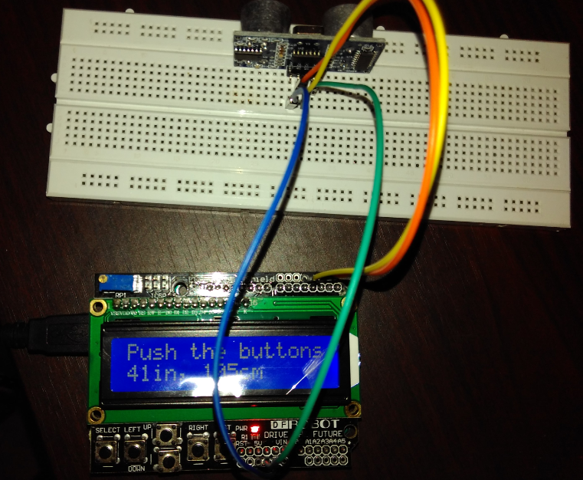

**Echo-pin 2**

**Trigger-pin 3**

**Vcc-5 V**

**Gnd-Gnd**

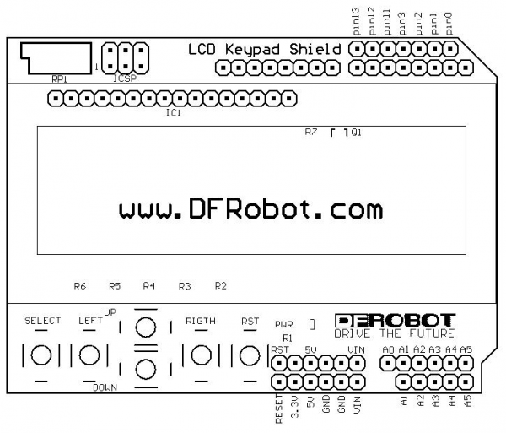

**Code:**

#include <LiquidCrystal.h>

const int trigPin = 3;

const int echoPin = 2;

LiquidCrystal lcd(8, 9, 4, 5, 6, 7); // select the pins used on the LCD panel

void setup() {

lcd.begin(16, 2); // start the library

lcd.setCursor(0,0); // set the LCD cursor position

}

void loop()

{

// establish variables for duration of the ping,

// and the distance result in inches and centimeters:

long duration, inches, cm;

lcd.setCursor(0,1); // move cursor to second line "1" and 0 spaces over

// The sensor is triggered by a HIGH pulse of 10 or more microseconds.

// Give a short LOW pulse beforehand to ensure a clean HIGH pulse:

pinMode(trigPin, OUTPUT);

digitalWrite(trigPin, LOW);

delayMicroseconds(2);

digitalWrite(trigPin, HIGH);

delayMicroseconds(10);

digitalWrite(trigPin, LOW);

// Read the signal from the sensor: a HIGH pulse whose

// duration is the time (in microseconds) from the sending

// of the ping to the reception of its echo off of an object.

pinMode(echoPin, INPUT);

duration = pulseIn(echoPin, HIGH);

// convert the time into a distance

inches = microsecondsToInches(duration);

cm = microsecondsToCentimeters(duration);

lcd.print(inches);

lcd.print("in, ");

lcd.print(cm);

lcd.print("cm");

delay(1000);

}

long microsecondsToInches(long microseconds)

{

return microseconds / 74 / 2;

}

long microsecondsToCentimeters(long microseconds)

{ return microseconds / 29 / 2;

}

**9. RFID Reader and RFID tag count**

**Aim:**

To count the number of RFID tags read by the RFID reader

**Hardware Required:**

* Arduino
* RFID Reader module
* RFID Tags

**Circuit diagram**

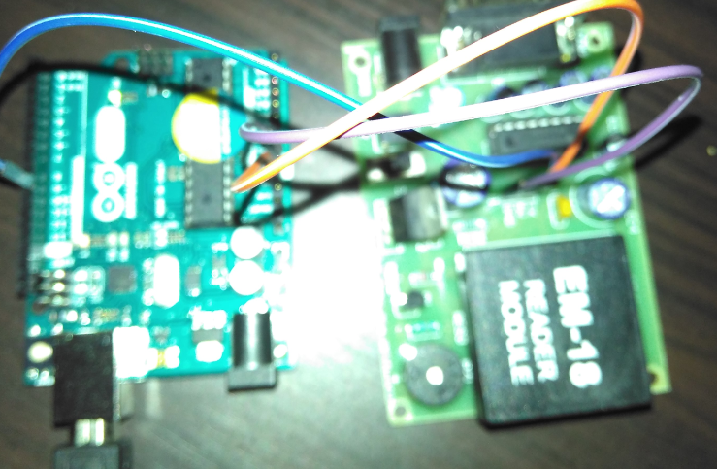

**Code:**

# **Reading the code present on RFID tag:**

The following code will read the code present on RFID tag and print it in serial monitor.

**Connection:**

5V-Arduino 5V GND-Arduino GND Tx-pin 9

**Code:**

#include<SoftwareSerial.h>

SoftwareSerial mySerial(9, 10);

int count = 0; // count = 0

char input[12]; // character array of size 12

boolean flag = 0; // flag =0

void setup()

{

Serial.begin(9600); // begin serial port with baud rate 9600bps

mySerial.begin(9600);

}

void loop()

{

if(mySerial.available())

{

count = 0;

while(mySerial.available() && count < 12) // Read 12 characters and store them in input array

{

input[count] =mySerial.read();

count++;

delay(5);

}

Serial.print(input); // Print RFID tag number

}

}

The output consists of 12 character ASCII data, where first 10 bits will be the tag number and last 2 bits will be the XOR result of the tag number which can be used for error correction. For eg : If the RFID tag number is 500097892E, output of EM-18 Reader will be 500097892E60, where **60 is 50 xor 00 xor 97 xor 89 xor 2E.**

# **Access control through RFID:**

The following code will read the code present on RFID tag tapped. If the code matches with the previously known tag(configured in the code), it will grant access(here LED will glow), otherwise access will be denied.

**Connection:**

5V-Arduino 5V GND-Arduino GND Tx-pin 9 Led-pin 12

**Code:**

#include<SoftwareSerial.h>

SoftwareSerial mySerial(9, 10);

#define LEDPIN 12

char tag[] ="3C0087D597F9"; // Replace with your own Tag ID

char input[12]; // A variable to store the Tag ID being presented

int count = 0; // A counter variable to navigate through the input[] character array

boolean flag = 0; // A variable to store the Tag match status

void setup()

{

Serial.begin(9600); // Initialise Serial Communication with the Serial Monitor

mySerial.begin(9600);

pinMode(LEDPIN,OUTPUT); //WRONG TAG INDICATOR

}

void loop()

{

if(mySerial.available())// Check if there is incoming data in the RFID Reader Serial Buffer.

{

count = 0; // Reset the counter to zero

/* Keep reading Byte by Byte from the Buffer till the RFID Reader Buffer is empty

or till 12 Bytes (the ID size of our Tag) is read */

while(mySerial.available() && count < 12)

{

input[count] = mySerial.read();

// Read 1 Byte of data and store it in the input[] variable

Serial.write(input[count]);

count++; // increment counter

delay(5);

}

/* When the counter reaches 12 (the size of the ID) we stop and compare each value

of the input[] to the corresponding stored value */

if(count == 12) //

{

count =0; // reset counter varibale to 0

flag = 1;

/* Iterate through each value and compare till either the 12 values are

all matching or till the first mistmatch occurs */

while(count<12 && flag !=0)

{

if(input[count]==tag[count])

flag = 1; // everytime the values match, we set the flag variable to 1

else

flag= 0;

/* if the ID values don't match, set flag variable to 0 and

stop comparing by exiting the while loop */

count++; // increment i

}

}

if(flag == 1) // If flag variable is 1, then it means the tags match

{

Serial.println("Access Allowed!");

digitalWrite(LEDPIN,HIGH);

delay (2000);

digitalWrite (LEDPIN,LOW);

}

else

{

Serial.println("Access Denied"); // Incorrect Tag Message

digitalWrite(LEDPIN,LOW);

delay(2000);

}

/* Fill the input variable array with a fixed value 'F' to overwrite

all values getting it empty for the next read cycle */

for(count=0; count<12; count++)

{

input[count]= 'F';

}

count = 0; // Reset counter variable

}

}

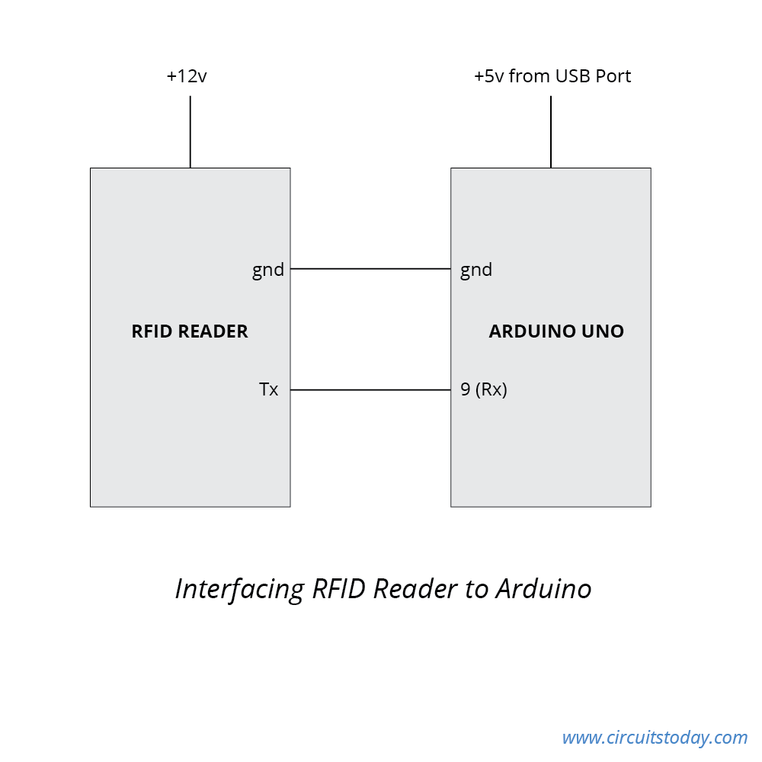

**10. Humidity and Temperature logging in a cloud**

**Aim:**

Storing the sensed sensor reading in the cloud.

**Hardware Required:**

* Arduino
* Humidity and temperature sensor

**Circuit diagram: (Using Ethernet shield)**

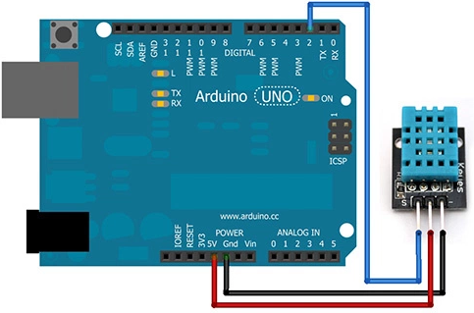

1. Create an account in <https://thingspeak.com/>
2. Create one new channel
3. Note down WriteAPI key and Channel ID
4. Attach Ethernet Shield on Arduino
5. Make connection with temperature and humidity sensor as in circuit diagram.
6. Install DHT11 library – See

http://www.circuitbasics.com/how-to-set-up-the-dht11-humidity-sensor-on-an-arduino/

1. Include the library in your code. Go to sketch->Include library and include DHT library

**Code:**

#include <dht.h>

#include <SPI.h>

#include <Ethernet.h>

dht DHT;

#define DHT11_PIN 7

// Local Network Settings

byte mac[] = { 0xD4, 0x28, 0xB2, 0xFF, 0xA0, 0xA1 }; // Must be unique on local network

// ThingSpeak Settings

char thingSpeakAddress[] = "api.thingspeak.com";

String writeAPIKey = "**IZMTTVC12FFAHTZH**"; //Replace with yours

unsigned long myChannelNumber = **132940**; //Replace with yours

const int updateThingSpeakInterval = 16 * 1000; // Time interval in milliseconds to update ThingSpeak (number of seconds * 1000 = interval)

// Variable Setup

long lastConnectionTime = 0;

boolean lastConnected = false;

int failedCounter = 0;

// Initialize Arduino Ethernet Client

EthernetClient client;

void setup(){

Serial.begin(9600);

// Start Ethernet on Arduino

startEthernet();

}

void loop()

{

int chk = DHT.read11(DHT11_PIN);

Serial.print("Temperature = ");

Serial.println(DHT.temperature);

Serial.print("Humidity = ");

Serial.println(DHT.humidity);

char t_buffer[10];

char h_buffer[10];

float t=(DHT.temperature);

String temp=dtostrf(t,0,5,t_buffer);

float h=(DHT.humidity);

String humid=dtostrf(h,0,5,h_buffer);

delay(1000);

// Disconnect from ThingSpeak

if (!client.connected() && lastConnected)

{

Serial.println("...disconnected");

Serial.println();

client.stop();

}

// Update ThingSpeak

if(!client.connected() && (millis() - lastConnectionTime > updateThingSpeakInterval))

{

updateThingSpeak("field1="+temp+"&field2="+humid);

}

// Check if Arduino Ethernet needs to be restarted

if (failedCounter > 3 ) {startEthernet();}

lastConnected = client.connected();

}

void updateThingSpeak(String tsData)

{

if (client.connect(thingSpeakAddress, 80))

{

client.print("POST /update HTTP/1.1\n");

client.print("Host: api.thingspeak.com\n");

client.print("Connection: close\n");

client.print("X-THINGSPEAKAPIKEY: "+writeAPIKey+"\n");

client.print("Content-Type: application/x-www-form-urlencoded\n");

client.print("Content-Length: ");

client.print(tsData.length());

client.print("\n\n");

client.print(tsData);

lastConnectionTime = millis();

if (client.connected())

{

Serial.println("Connecting to ThingSpeak...");

Serial.println();

failedCounter = 0;

}

else

{

failedCounter++;

Serial.println("Connection to ThingSpeak failed ("+String(failedCounter, DEC)+")");

Serial.println();

}

}

else

{

failedCounter++;

Serial.println("Connection to ThingSpeak Failed ("+String(failedCounter, DEC)+")");

Serial.println();

lastConnectionTime = millis();

} }

void startEthernet()

{

client.stop();

Serial.println("Connecting Arduino to network...");

Serial.println();

delay(1000);

// Connect to network amd obtain an IP address using DHCP

if (Ethernet.begin(mac) == 0)

{

Serial.println("DHCP Failed, reset Arduino to try again");

Serial.println();

}

else

{

Serial.println("Arduino connected to network using DHCP");

Serial.println();

}

delay(1000);

}

After uploading, check your channel status in thingsspeak.

**11.2 Using Wifi**

**CLOUD (SPARKFUN)**

**Cloud Data:**

[**https://data.sparkfun.com/streams/QGyLQKYb71F2Q1qMqQER**](https://data.sparkfun.com/streams/QGyLQKYb71F2Q1qMqQER)

**Pushing data to cloud (Only for reference)**

Pusing data to cloud is done by the program in Arduino. However sometime we might want to push manually from browser just for testing. Use below url for that

[**https://data.sparkfun.com/input/QGyLQKYb71F2Q1qMqQER?private_key=JqyBXeWg9ViqeBy9yevR&temperature=33.33**](https://data.sparkfun.com/input/QGyLQKYb71F2Q1qMqQER?private_key=JqyBXeWg9ViqeBy9yevR&temperature=33.33)

**Pin Diagram of ESP8266**

[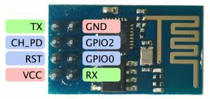](http://kayarvizhy.com/wp-content/uploads/2016/05/ESP8266_pin.jpg)

**Connections**

|  |  |  |
| --- | --- | --- |
| **Arduino** | **ESP8266** | **DHT Temperature sensor** |
| 5V | CH_PD, RST, VCC |  |
| 3.3V |  | VCC |
| GND | GND | GND |
| 2 (Software Serial RX) | TX |  |
| 3 (Software Serial TX) | RX |  |
| 5 |  | DATA |

**IMPORTANT**

Change the WIFI name and password in the program before uploading. Also the program might show disconnect few times

POST /input/QGyLQKYb71F2Q1qMqQER?private_key=JqyBXeWg9ViqeBy9yevR&temperature=29.0000 HTTP/1.0

Host: data.sparkfun.com

connect timeout

**but will succeed and say**

POST /input/QGyLQKYb71F2Q1qMqQER?private_key=JqyBXeWg9ViqeBy9yevR&temperature=29.0000 HTTP/1.0

Host: data.sparkfun.com

>

Recv 126 aytes

SEND OK

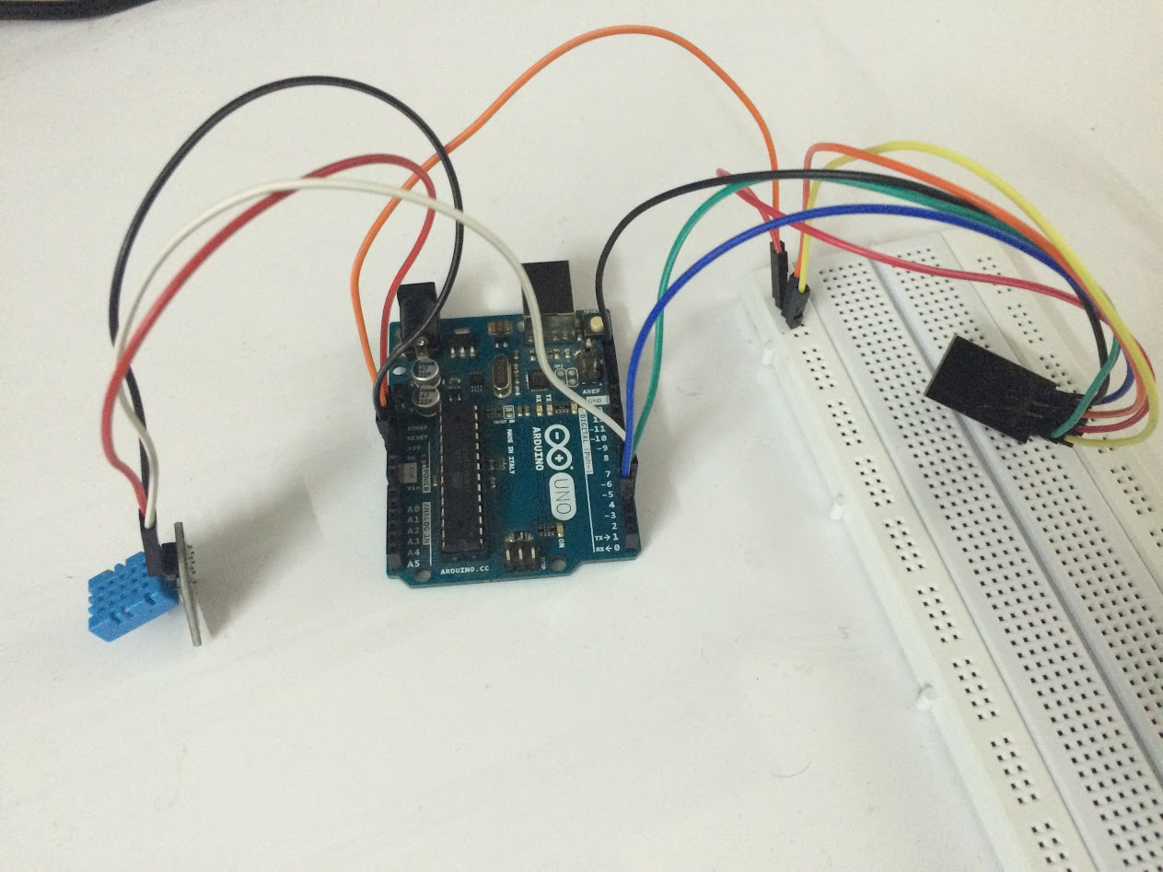

**IMPORTANT**

**When uploading the sketch you might have to disconnect the VCC to ESP8266 to avoid upload failure**

**Code**

#include <SoftwareSerial.h>

//use mega Serial 2 for serial monitor; Serial 1 on pins 19 (RX) and 18 (TX);// Serial2 on pins 17 (RX) and 16 (TX), Serial3 on pins 15 (RX) and 14 (TX).

//#define SSID "SSID"

//#define PASS "Password"

#include <dht.h>

dht DHT;

#define DHT11_PIN 5

#define SSID "NAME OF WIFI"

#define PASS "PASSWORD"

#define DST_IP "data.sparkfun.com" //baidu.com

SoftwareSerialSerial2(2,3);

float temp;

intpintemp = A0;

//SoftwareSerialdbgSerial(10, 11); // RX, TX

// Use DHT11 sensor

void setup()

{

// Open serial communications and wait for port to open:

//serial 2 is to esp8266

Serial2.begin(115200);//9600 (mine), 57600, 115200

Serial2.setTimeout(1000);

//serial 0 is to usb

Serial.begin(9600);

while(!Serial);

while(!Serial2);

//dbgSerial.begin(9600); //can't be faster than 19200 for softserial

//dbgSerial.println("ESP8266 Demo");

Serial.println("ESP8266 Demo on Mega2560");

while(Serial2.available()>0)

Serial2.read();

Serial2.println("AT");

delay(1000);

while (Serial2.available())

{

char c = Serial2.read();

//dbgSerial.write(c);

Serial.write(c);

//if(c=='\r') dbgSerial.print('\n');

if(c=='\r') Serial.print('\n');

}

Serial.print('\n');

delay(1000);

Serial2.flush();

Serial2.println("AT+RST");

delay(1000);

while (Serial2.available())

{

char c = Serial2.read();

//dbgSerial.write(c);

Serial.write(c);

//if(c=='\r') dbgSerial.print('\n');

if(c=='\r') Serial.print('\n');

}

Serial.print('\n');

delay(1000);

Serial2.flush();

Serial2.println("AT+GMR");

delay(1000);

while (Serial2.available())

{

char c = Serial2.read();

//dbgSerial.write(c);

Serial.write(c);

//if(c=='\r') dbgSerial.print('\n');

if(c=='\r') Serial.print('\n');

}

Serial.print('\n');

delay(1000);

Serial2.flush();

Serial2.println("AT+CIFSR");

delay(1000);

while (Serial2.available())

{

char c = Serial2.read();

//dbgSerial.write(c);

Serial.write(c);

//if(c=='\r') dbgSerial.print('\n');

if(c=='\r') Serial.print('\n');

}

Serial.print('\n');

delay(1000);

Serial2.flush();

Serial2.println("AT+CWMODE=3");

delay(1000);

while (Serial2.available())

{

char c = Serial2.read();

//dbgSerial.write(c);

Serial.write(c);

//if(c=='\r') dbgSerial.print('\n');

if(c=='\r') Serial.print('\n');

}

Serial.print('\n');

delay(2000);

Serial2.flush();

Serial2.println("AT+CWLAP");

delay(2000);

while (Serial2.available())

{

char c = Serial2.read();

//dbgSerial.write(c);

Serial.write(c);

//if(c=='\r') dbgSerial.print('\n');

if(c=='\r') Serial.print('\n');

}

Serial.print('\n');

delay(2000);

Serial2.flush();

String cmd="AT+CWJAP=\"";

cmd+=SSID;

cmd+="\",\"";

cmd+=PASS;

cmd+="\"";

Serial2.println(cmd);

Serial.println(cmd);

delay(2000);

while (Serial2.available())

{

char c = Serial2.read();

//dbgSerial.write(c);

Serial.write(c);

//if(c=='\r') dbgSerial.print('\n');

if(c=='\r') Serial.print('\n');

}

delay(2000);

Serial.print('\n');

Serial2.flush();

/*

//test if the module is ready

Serial2.println("AT+RST");

//delay(1000);

//delay(1000);

Serial.println("Resetting module");

Serial2.flush();

//if(Serial2.find("ready"))

if(Serial2.find("Ready")||Serial2.find("ready"))

{

//dbgSerial.println("Module is ready");

Serial.println("Module is ready");

}

else

{

//dbgSerial.println("Module have no response.");

Serial.println("Module have no response.");

while(1);

}

delay(1000);

//connect to the wifi

boolean connected=false;

for(inti=0;i<5;i++)

{

if(connectWiFi())

{

connected = true;

break;

}

}

if (!connected){while(1);}

delay(5000);

//print the ipaddr

/*

Serial2.println("AT+CIFSR");

Serial.println("ip address:");

while (Serial2.available())

Serial.write(Serial2.read());

//set the single connection mode

Serial2.println("AT+CIPMUX=0");

*/

}

void loop()

{

// Read temperature as Celsius

Serial.print("DHT11, \t");

intchk = DHT.read11(DHT11_PIN);

switch (chk)

{

case DHTLIB_OK:

Serial.print("OK,\t");

break;

case DHTLIB_ERROR_CHECKSUM:

Serial.print("Checksum error,\t");

break;

case DHTLIB_ERROR_TIMEOUT:

Serial.print("Time out error,\t");

break;

case DHTLIB_ERROR_CONNECT:

Serial.print("Connect error,\t");

break;

case DHTLIB_ERROR_ACK_L:

Serial.print("Ack Low error,\t");

break;

case DHTLIB_ERROR_ACK_H:

Serial.print("Ack High error,\t");

break;

default:

Serial.print("Unknown error,\t");

break;

}

int temp = DHT.temperature;

#if 1

String cmd = "AT+CIPSTART=\"TCP\",\"";

cmd += DST_IP;

cmd += "\",80";

Serial2.println(cmd);

//dbgSerial.println(cmd);

Serial.println(cmd);

if(Serial2.find("Error")) return;

//cmd = "GET / HTTP/1.0\r\n\r\n";

//cmd = "POST /input/QGyLQKYb71F2Q1qMqQER?private_key=JqyBXeWg9ViqeBy9yevR&temperature=40 HTTP/1.0\r\n\r\n Host: data.sparkfun.com\r\n\r\n";

char s[200];

Serial.println(temp);

int t1 = temp;

float f2 = temp-t1;

int t2 = trunc(f2 * 10000);

sprintf (s, "POST /input/QGyLQKYb71F2Q1qMqQER?private_key=JqyBXeWg9ViqeBy9yevR&temperature=%d.%04d HTTP/1.0\r\n\r\n Host: data.sparkfun.com\r\n\r\n", t1,t2);

Serial.println(s);

cmd = s;

Serial.println(cmd);

Serial2.print("AT+CIPSEND=");

Serial2.println(cmd.length());

if(Serial2.find(">"))

{

//dbgSerial.print(">");

Serial.print(">");

}else

{

Serial2.println("AT+CIPCLOSE");

//dbgSerial.println("connect timeout");

Serial.println("connect timeout");

delay(1000);

return;

}

Serial2.print(cmd);

delay(2000);

//Serial.find("+IPD");

while (Serial2.available())

{

char c = Serial2.read();

//dbgSerial.write(c);

Serial.write(c);

//if(c=='\r') dbgSerial.print('\n');

if(c=='\r') Serial.print('\n');

}

//dbgSerial.println("====");

Serial.println("====");

delay(1000);

#endif

}

booleanconnectWiFi()

{

Serial2.println("AT+CWMODE=1");

String cmd="AT+CWJAP=\"";

cmd+=SSID;

cmd+="\",\"";

cmd+=PASS;

cmd+="\"";

//dbgSerial.println(cmd);

Serial2.println(cmd);

Serial.println(cmd);

delay(2000);

if(Serial2.find("OK"))

{

//dbgSerial.println("OK, Connected to WiFi.");

Serial.println("OK, Connected to WiFi.");

return true;

}else

{

//dbgSerial.println("Can not connect to the WiFi.");

Serial.println("Can not connect to the WiFi.");

return false;

}

}